- create XML file for refering the DTD file

1.<!DOCTYPE TVSCHEDULE [
<!ELEMENT TVSCHEDULE (CHANNEL+)>
<!ELEMENT CHANNEL (BANNER,DAY+)>
<!ELEMENT BANNER (#PCDATA)>
<!ELEMENT DAY (DATE,(HOLIDAY|PROGRAMSLOT+)+)>
<!ELEMENT HOLIDAY (#PCDATA)>
<!ELEMENT DATE (#PCDATA)>
<!ELEMENT PROGRAMSLOT (TIME,TITLE,DESCRIPTION?)>
<!ELEMENT TIME (#PCDATA)>
<!ELEMENT TITLE (#PCDATA)>
<!ELEMENT DESCRIPTION (#PCDATA)>
<!ATTLIST TVSCHEDULE NAME CDATA #REQUIRED>
<!ATTLIST CHANNEL CHAN CDATA #REQUIRED>
<!ATTLIST PROGRAMSLOT VTR CDATA #IMPLIED>
<!ATTLIST TITLE RATING CDATA #IMPLIED>
<!ATTLIST TITLE LANGUAGE CDATA #IMPLIED>
]>

2.<!DOCTYPE NEWSPAPER [
<!ELEMENT NEWSPAPER (ARTICLE+)>
<!ELEMENT ARTICLE (HEADLINE,BYLINE,LEAD,BODY,NOTES)>
<!ELEMENT HEADLINE (#PCDATA)>
<!ELEMENT BYLINE (#PCDATA)>
<!ELEMENT LEAD (#PCDATA)>
<!ELEMENT BODY (#PCDATA)>
<!ELEMENT NOTES (#PCDATA)>
<!ATTLIST ARTICLE AUTHOR CDATA #REQUIRED>
<!ATTLIST ARTICLE EDITOR CDATA #IMPLIED>
<!ATTLIST ARTICLE DATE CDATA #IMPLIED>
<!ATTLIST ARTICLE EDITION CDATA #IMPLIED>
<!ENTITY NEWSPAPER "Vervet Logic Times">
<!ENTITY PUBLISHER "Vervet Logic Press">
<!ENTITY COPYRIGHT "Copyright 1998 Vervet Logic Press">
]>

- <!DOCTYPE CATALOG [
<!ENTITY AUTHOR "John Doe">
<!ENTITY COMPANY "JD Power Tools, Inc.">
<!ENTITY EMAIL "jd@jd-tools.com">
<!ELEMENT CATALOG (PRODUCT+)>
<!ELEMENT PRODUCT
(SPECIFICATIONS+,OPTIONS?,PRICE+,NOTES?)>
<!ATTLIST PRODUCT
NAME CDATA #IMPLIED
CATEGORY (HandTool|Table|Shop-Professional) "HandTool"
PARTNUM CDATA #IMPLIED
PLANT (Pittsburgh|Milwaukee|Chicago) "Chicago"
INVENTORY (InStock|Backordered|Discontinued) "InStock">
<!ELEMENT SPECIFICATIONS (#PCDATA)>
<!ATTLIST SPECIFICATIONS
WEIGHT CDATA #IMPLIED
POWER CDATA #IMPLIED>
<!ELEMENT OPTIONS (#PCDATA)>
<!ATTLIST OPTIONS
FINISH (Metal|Polished|Matte) "Matte"
ADAPTER (Included|Optional|NotApplicable) "Included"
CASE (HardShell|Soft|NotApplicable) "HardShell">
<!ELEMENT PRICE (#PCDATA)>
<!ATTLIST PRICE
MSRP CDATA #IMPLIED
WHOLESALE CDATA #IMPLIED
STREET CDATA #IMPLIED
SHIPPING CDATA #IMPLIED>
<!ELEMENT NOTES (#PCDATA)>
]>

Case Study – CCSS

Credit Card Statement System (CCSS) receives credit card statements in XML documents.
CCSS processes these credit card statements
The processing includes displaying the credit card statements in HTML form and preparing a list of credit card holders whose total amount due exceeds a specified amount
CCSS receives multiple XML documents in a month
Each XML document contains credit card statements of multiple account holders.
A credit card statement contains several attributes listed as follows:
» Full name of the card holder
» Account number of the card holder
» Statement date
» Payment due date
» Minimum amount due
Credit limit including the cash limit
» Cash limit, which is included in the credit limit
» Available credit limit
» Available cash limit
Account Summary section contains the following attributes:
» Opening balance
» Purchases and other charges during this month
» Payments and other credits during this month
Transactions section contains multiple transactions. Each transaction contains the following attributes:
» Transaction date
» Transaction description
» Transaction amount
» Transaction type that is, C for credit and D for debit
Total amount due must be computed:
Total amount due = opening balance + purchases – payments
» For example: If you owe Rs.10000 to the credit card company as on the previous statement date, then your opening balance is Rs.10000.
» From that date, if you make purchases worth 40000 and pay 30000, then your total amount due will be: 10000 + 40000 – 30000 = 20000.

- Problem Statement:
Study the Credit Card Statement System (CCSS) case study and prepare a sample XML document. The root element of the XML document must be <creditCardStatements>. This document can contain multiple credit card statements. The name of this element must be <creditCardStatement>.The following names must be used for other elements described in the case study:
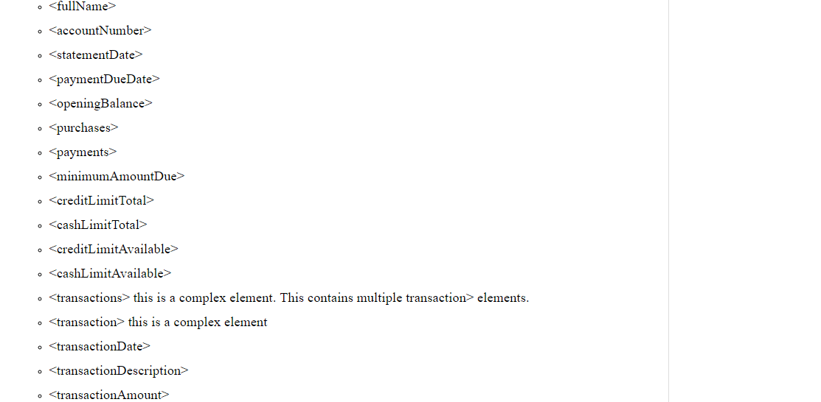
<transactionType>
Deliverables Expected:
A sample XML document called ccssdata.xml

- Write a DTD for the XML document in CCSS.
- Write a schema for the XML document in CCSS.
- Write an XPath expression to print the names of all credit card holders in the XML document.
- Write an XPath expression to print the names of those credit card holders, whose total amount due exceeds Rs. 25,000.
- Write an XSLT to generate a HTML document containing all credit card holders and their total amounts due. The data must be displayed in the form of a HTML table with the name of credit card holder in one column and their total amounts due in another column.
- Write an XSLT to generate a HTML document displaying all the information available in the XML document.

